**OFFICE OF THE BARANGAY CHAIRMAN**

**C E R T I F I C AT E O F R E S I D E N C Y**

**TO WHOM IT MAY CONCERN:**

THIS IS TO CERTIFY that, **JOSIL M. CABULAO** is a bonafide resident of thisbarangay with postal address at # 64 Makiling Street Palar, Barangay Post Proper Southside, Taguig City.

This certification is issued upon request of subject person for **Bail Bond Guarantor.**

Issued this 24th day of March 2025 at the Barangay Hall Post Proper Southside, Lawton Avenue, Taguig City.

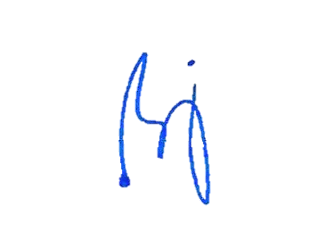

**QUIRINO V. SARONO**

Punong Barangay

NOTE: NOT VALID WITHOUT BARANGAY SEAL

NOT VALID WITH ALTERATION/S OR ERASURE

Valid only within 90 days from the date issued.